

Université Mohammed V de Rabat
École nationale supérieure d’informatique et d’analyse des systèmes

Digital engineering for finance

Advanced machine learning project report

Stock price prediction using machine learning

Supervising professors:
- Mr. Achchab Said
- Mrs. SlimaniIlham
- Mrs. Bousqaoui Halima
Made by:
- OthmaneAkhsas
- Yassine Abouhadid
- Amine Hibatallah
- Yassine Boutouar

Academic year: 2020/2021

Acknowledgements

We are extremely thankful for the precious support we got throughout the duration of this semester from our supervisors Mr. Achchab Said, Mrs. Slimani Ilham and Mrs. Bousqaoui Halima. This project and the research behind it would not have been possible without their exceptional help. Their guidance, knowledge and exacting attention to detail kept our work on track from our first encounter to the final draft of this paper.
We also feel grateful toward all our other teachers of Computer Science. They instilled invaluable skills that helped us throughout this project and more.
Moreover, we would like to thank people in our entourage especially our families and friends for their moral support they showed us through both good and bad times.
Finally, we would like to thank anyone taking the time and effort to read this report which we hope will be an interesting read for you.

Table of contents
Contents
Introduction 4
I. Article summary 5
1. Abstract 5
2. Introduction 5
3. Models used: 5
4. Data and preprocessing 6
5. Conclusion 6
II. Problem 6
III. Data preprocessing 7
1. Dataset description 7
a. Apple Inc. (AAPL) 7
b. Coca-Cola Company (KO) 9
2. Preprocessing 10
a. Split Data 10
b. New columns 11
c. Deleting Nan variables 13
IV. Description of the models used 13
1. Simple linear regression 14
2. Regression Decision tree 14
3. Random Forest 14
4. K-nearest Neighbors 15
5. Neural networks 15
6. Recurrent neural networks 15
7. LSTM (Long Short-Term Memory) 16
V. Models Implementation 17
1. linear regression 17
2. Decision Tree Regressor 18
3. Random Forest Regressor 20
4. K-Neighbors 22
5. Neural Network 27
6. Recurrent neural network : LSTM 29
Conclusion 34
References 35

Table of figures:

Figure 1: Apple dataset display
Figure 2: Apple adjusted closing price evolution curve
Figure 3: Apple histogram of the daily percent of adjusted closing price
Figure 4: Coca-Coladataset display
Figure 5: Coca-Cola adjusted closing price evolution curve
Figure 6: Coca-Cola histogram of the daily percent of adjusted closing price
Figure 7: Scatter of the current 5-day percent change vs the future 5-day percent change
Figure 8:the correlation matrix between the 5d close percentage changes
Figure 9:heatmap of correlation matrix between all the features
Figure 10:Number of nan values in each column
Figure 11:Linear model training set graph
Figure 12: Linear model test set graph
Figure 13:Decision Tree training set graph
Figure 14: Decision Tree test set graph
Figure 15:Random Forest training set graph
Figure 16: Random Forest test set graph
Figure 17: K-Neighbors training set graph
Figure 18: K-Neighbors test set graph
Figure 19:Model implementation
Figure 20:Loss curve
Figure 21:Neural Network Training set graph
Figure 22: Neural Network Test set graph
Figure 23: LSTM algorithm code
Figure 24: LSTM loss curve
Figure 25: LSTM Training+Test set graph (Apple dataset)
Figure 26: LSTM Training+Test set graph (Apple dataset)
Figure 27: LSTM Test set graph (Coca-Cola dataset: row 200 to 400)
Figure 28: LSTM Test set graph (Coca-Cola dataset: row 1000 to 1200)
Figure 29: LSTM Test set graph (Coca-Cola dataset: row 2100 to 2200)
Figure 30: LSTM Test set graph (Coca-Cola dataset: row 3100 to 3200)

Abstract

Accurate stock market returns forecasting is one of the challenging tasks because the volatility and the highly non-linear nature of these markets. With the introduction of the artificial intelligence models, programmed methods of prediction have proved to be efficient in forecasting future stock prices.
This paper takes a try in predicting stock market prices using historical data records and machine learning algorithm. It focuses on predicting future closing prices of Apple Inc.’s stock (NASDAQ: AAPL) using various machine learning models with different complexity levels.
Neural network models (especially LSTM) showed better results because they tend to emulate human decision-making in the presence of underlying nonlinear input-output relationships in noisy signal environments.

Keywords

Machine Learning – Finance – Stock Market – Artificial intelligence – Prediction – LSTM.

Introduction

The stock market is a trading site where investors can sell and buy shares based on stock availability. The profit of stakeholders is affected by the stock market's ups and downs. Stakeholders benefit from their purchased stocks if market prices rise with available stock. In the event that the market falls and experiences a dip in stock prices, stakeholders will suffer losses. Buyers purchase stocks when the price is low and sell them at high prices in the hopes of making a large profit. Similarly, sellers benefit from selling their stocks at high prices.
Volatility, randomness, and unpredictability are all hallmarks of the stock market. It's a volatile environment with an enormous, constantly shifting stream of data, making it difficult to forecast and take advantage of those predictions in order to make a profit. In reality, it is one of the most difficult tasks in time series forecasting.Physical vs. psychological factors, rational vs. irrational behaviour, and so on are all factors in the prediction. Both of these factors combine to make stock prices extremely volatile and difficult to forecast accurately.
The main aim of this project is to research and apply machine learning and deep learning techniques to the stock market in order to forecast stock prices and then act on those forecasts to minimize investment risk and maximize benefit. The aim is to use different machine learning models to make prediction on stock prices. After that, the predictions are compared to real historical stock price records.
We start by summarizing one of the research papers we have read, we then define the problem at hand to be resolved. Next, we describe the datasets used and the preprocessing steps that we followed. And finally, we present each model and we implement it using our datasets, to end it with our interpretations of the results.

- Article summary
Intelligent forecasting with machine learning trading systems in chaotic intraday Bitcoin market
By: Salim Lahmiri , Stelios Bekiros
- Abstract

The purpose of this paper was to evaluate some artificial intelligence systems in predicting Bitcoin price series, the data available being noisy and highly nonlinear. It studied the possibilities of forecasting high frequency Bitcoin price series using historical data and machine learning algorithms.
Results proved that the BRNN renders an outstanding accuracy in forecasting. In fact, artificial neural networks showed better results because they tend to emulate information processing as performed inside human cortex.

- Introduction
Recently, the accurate prediction of cryptocurrencies is a point of special interest for scholars and quantitative traders who focus on modeling time series in order to generate profits.
Cryptocurrency market is characterized as dynamic, unpredictable and non-linear in nature. Thus, forecasting prices is a challenging task as it depends on various factors.
- Models used:
Three different sets of models were used:
- statistical machine learning: support vector regressions (SVR) and Gaussian Poisson regressions (GRP).
- algorithmic models: regression trees (RT) and the k-nearest neighbors (KNN).
- artificial neural network topologies: feedforward (FFNN), Bayesian regularization (BRNN) and radial basis function networks (RBFNN).

The authors presented a detailed description of the seven models used, pointing advantages and disadvantages of every and each one of them.
After applying the seven models, Bayesian optimization is employed in order to find optimal values for the SVR, GRP, and KNN algorithms.

- Data and preprocessing
The total sample size is 65,535 observations.
For each machine learning model, the first 80% of the dataset is employed for training while the remaining 20% for testing.
The seven models forecast the next 5-minute step price level of Bitcoin, whilst the previous five observations are used as inputs, for each predictive system.

- Conclusion
Results show that the BRNN renders an outstanding accuracy in forecasting, while its convergence is unhindered and remarkably fast. The overall superiority of artificial neural networks is due to parallel processing features that efficiently emulate human decision-making in the presence of underlying nonlinear input-output relationships in noisy signal environments.

- Problem
Accurately predicting the prices of stocks is a difficult task for machine learning and artificial intelligence researchers because of price volatility. One of the most intricate machine learning problems is the share value prediction. It depends on a variety of factors that affect supply and demand.
The stock market is known for its volatility, randomness, and unpredictability. It is a chaotic place with an unbelievably huge continuously changing stream of data which makes predicting and acting on those predictions to make a profit very hard. It is actually one of the most challenging tasks in times series forecasting.
Prices of stocks are depicted by time series data and neural networks are trained to learn the patterns from trends in the existing data.
The problem we will try to solve will be to predict the price of a few stocks through Machine Learning and Deep Learning models and make comparisons between them to finally arrive at relevant conclusions.

- Data preprocessing
- Dataset description
We obtained the data used in this project from RefinitivEikon, a platform for financial professionals to help them analyse financial data.
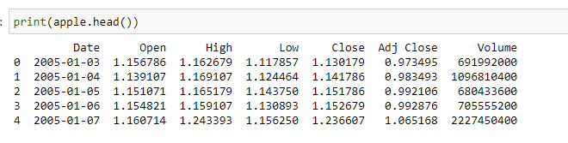
- Apple Inc. (AAPL)

Figure 1 : Apple dataset display

Our dataset for Apple Inc. consists of 7 columns in addition to an indexing column.
- Date: represents the date that matches the other columns data.
- Open: represents the opening price, which is the price at which a security first trades at the opening of the exchange on a trading day.
- High: represents the high price, the highest price at which the security trades on that day.
- Low: represents the low price, the lowest price at which the security trades on that trading day.
- Close: represents the closing price, which is the price at which a security last trades before the closing of the exchange on a trading day.
- Adj Close: Adjusted closing price, reflect that stock's closing value after accounting for any corporate actions.
- Volume: the amount of an asset or security that changes hands over the trading day.

- The dataset has 4086 rows, containing daily historical data of the stock from 03/01/2005 to 20/03/2021.
The following figure represents Apple adjusted closing price evolution:

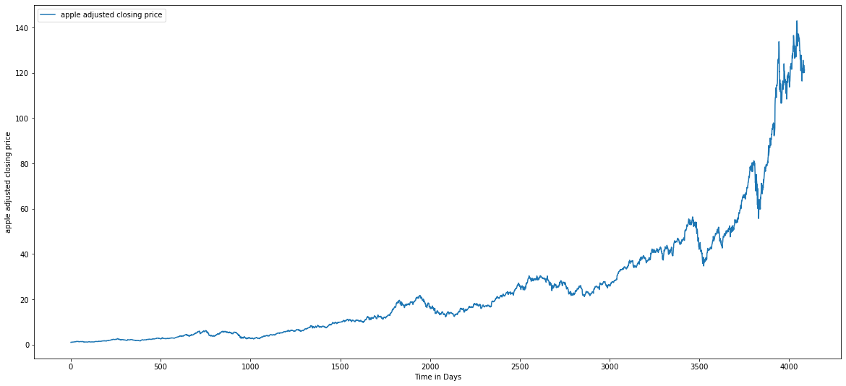

Figure 2: Apple Adjusted closing price evolution curve

The following figure represents the histogram of the daily price change percent of Adjusted closing price for Apple:

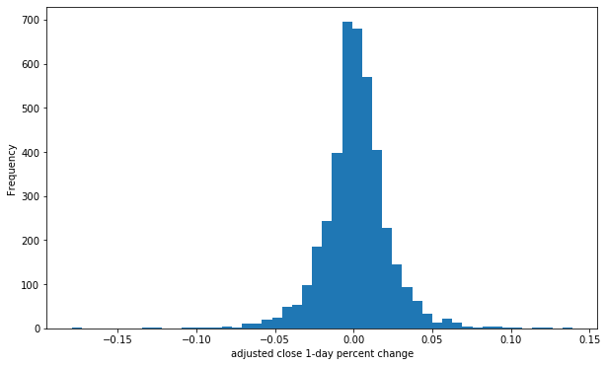

Figure 3:histogram of the daily percent of adjusted closing price

- Coca-Cola Company (KO)
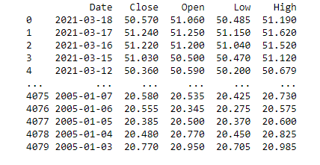
The dataset’s columns are similar to those of apple data

Figure 4: Coca-Cola dataset display

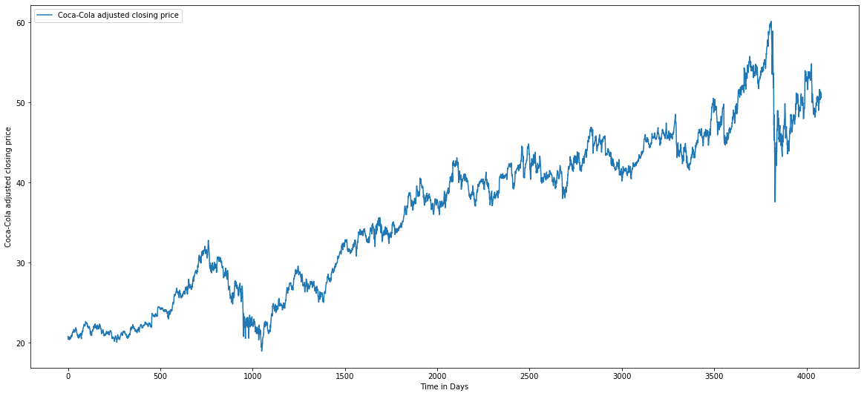
Coca-Cola adjusted closing price evolution:

Figure 5: Coca-Cola adjusted closing price evolution curve

The following figure represents the histogram of the daily price change percent of Adjusted closing price for Coca-Cola:
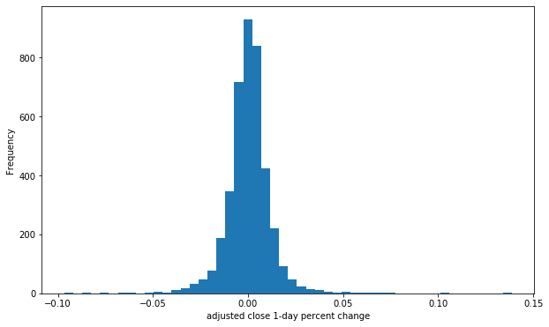

Figure 6: Coca-Cola histogram of the daily price change percent of adjusted closing price

- Preprocessing
After this description of the data used, we’re advancing to the preprocessing part of the project, this part is crucial to get good results.

- Split Data
The dataset was split as follows:
- Training data: historical data of apple stock from 2005 to 2017;
- Testing data: historical data of apple stock from 2018 to 2017, plus the whole dataset of Coca-Cola.

- New columns
In order to achieve the best results possible, we decided to add new features based on the columns that already exist:
- 5d_close_pct: Closing price percentage change over the last 5 days.
- 5d_close_future_pct: Closing price percentage change over the next 5 days.
- Moving average for 5,14,30 days: calculated by adding up all the data points during a specific period and dividing the sum by the number of time periods.
SMA = $\frac{A_{1}+A_{2+ … +}A_{n}}{n}$
Where:
A = average in period n
n = Number of time periods
- Relative strength index for 5,14,30 days: measures the magnitude of recent price changes to evaluate overbought or oversold conditions in the price of a stock.
$${RSI}_{step one}=100-[\frac{100}{1+\frac{average gain}{average loss}}]$$

The following figure represents the scatter of the current 5-day percent change vs the future 5-day percent change:
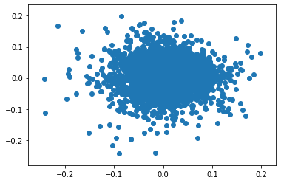
Figure 7: Scatter of the current 5-day percent change vs the future 5-day percent change

The following figure represents the correlation matrix between the 5d close pecentage changes (current and future): 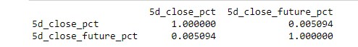
Figure 8: the correlation matrix between the 5d close percentage changes:
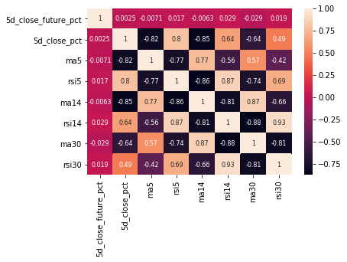
The following figure represents the heatmap of correlation matrix:
Figure 9: heatmap of correlation matrix between all the features

- Deleting Nan variables
The existence of Nan values has a negative impact on the training of the data, for this it is necessary to delete them
The following figure represents the number of nan values in each column
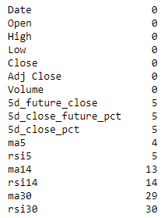
Figure 10: Number of nan values in each column

- Libraries used

In order to work on the pre-processing and using some models we used some libraries that helped us in our tasks:
- Numpy
- Pandas
- Matplotlib
- TA-lib
- Sickit Learn
- Keras

- Description of the models used
Artificial intelligence: A set of theories and techniques implemented to create machines capable of simulating human intelligence, of reasoning, of learning, of deciding, of seeing laughter and of feeling emotions. Machine Learning is a field of study of artificial intelligence which concerns the design, analysis, development and implementation of methods allowing a machine to evolve through a systematic process.

Machine Learning: Is a computer programming technique that uses statistical probability to give computers the ability to learn on their own without explicit programming. For its basic purpose, machine learning "teaches" computers - and subsequently, to act and react - as humans do, improving their learning style and knowledge autonomously over time. The ultimate goal would be for computers to act and react without being explicitly programmed for these actions and reactions. Machine learning uses development programs that adjust each time they are exposed to different types of input data.

- Simple linear regression
This method consists in finding the best function allowing to define an output variable (the element to be predicted) from a single and unique input explanatory variable (the predictor).

- RegressionDecisiontree
This decision support or data exploration tool allows you to represent a set of choices in the graphic form of a tree
Concretely, a decision tree models a hierarchy of tests to predict a result
There are two main types of decision trees:
Regression trees can predict a real quantity, a numerical value (for example, the price of a house or the length of stay of a patient in a hospital);
Classification trees make it possible to predict to which class the output variable belongs (for example this allows a population of individuals, such as customers of a company, to be divided into different types of profiles).

The possible decisions are located at the ends of the branches (the "leaves" of the tree) and are reached based on decisions made at each stage.

- RandomForest

In a Random Forest, we build a "forest of trees" (therefore, several decision trees), at random.
the decision is made by making all the trees "vote" and choosing the majority response (for a discrete choice) or the average of the responses (for a continuous variable).

- K-nearest Neighbors

(k-NN or even KNN or k nearest neighbours’ method): It is a standard classification algorithm which is based exclusively on the choice of the classification metric. It is “non-parametric” (only k needs to be set) and is based only on training data.
The idea is as follows: from a labeled database, we can estimate the class of a new data item by looking at what is the majority class of the k closest neighbouring data (hence the name of the algorithm). The only parameter to set is k, the number of neighbours to consider.
the algorithm can also be adapted for regression.

- Neuralnetworks

Neural networks are mathematical functions with several parameters, adjustable. As in neurons in the brain where connections are created, disappeared or strengthened according to different stimuli and produce an action, artificial (or formal) neural networks adjust parameters (called synaptic weights in reference to the biological functioning of the brain) based on input data to provide the best possible response.
In machine learning, a neuron makes a linear combination of the inputs it receives, to which it adds a value called bias. A nonlinear function, called activation, (such as hyperbolic tangent, for example) is then applied to the output value. This value is then passed to the next neuron layer. Each neuron thus performs a very rudimentary calculation, and it is the succession of layers of neurons that makes it possible to obtain complex networks. During this so-called "training" phase, the network will automatically adjust the parameters of each neuron, that is to say the values ​​of the weights and of the bias in order to minimize the average error calculated on all the examples between the expected output and that observed.

- Recurrentneuralnetworks
Recurrent Neural Networks (or RNNs for Recurrent Neural Networks) are networks of neurons in which information can travel in both directions, including from the deep layers to the first layers. These networks have recurring connections in the sense that they keep information in memory: they can take into account at any time t a certain number of past states. For this reason, RNNs are particularly suited to applications involving the context, and more particularly to the processing of temporal sequences. However, for applications involving long time deviations, this "short-term memory" is not sufficient. Indeed, "classic" RNNs (simple recurrent neural networks or Vanilla RNNs) are only able to memorize the so-called near past, and begin to "forget" after about fifty iterations. This two-way transfer of information makes their training much more complicated, and it is only recently that effective methods such as LSTMs (Long Short-Term Memory) have been developed.

- LSTM (LongShort-TermMemory)

Proposed by Hochreiter&Schmidhuber (1997) and since then has been modified by many researchers. The LSTM architecture consists of a collection of subnets, known as blocks of memory. Each memory block consists of:
- the memory cell - stores the state
- the front door - controls what to learn
- the door of oblivion - controls what to forget
- the exit door - controls the amount of content to modify

This memory block therefore allows us to:
- Forget (clear memory)
- Input (add to memory)
- Output (recover memory)

RNNs built with LSTM units categorize data into short-term and long-term memory cells. RNNs can thus determine which data is important and must be stored and reintegrated into the network, and what data can be forgotten.

- Models Implementation
- linear regression
After importing the statsmodels.api library with the alias sm we can use its function called OLS in order to create the linear model with the least squares fit and fit it on our training data
Training set

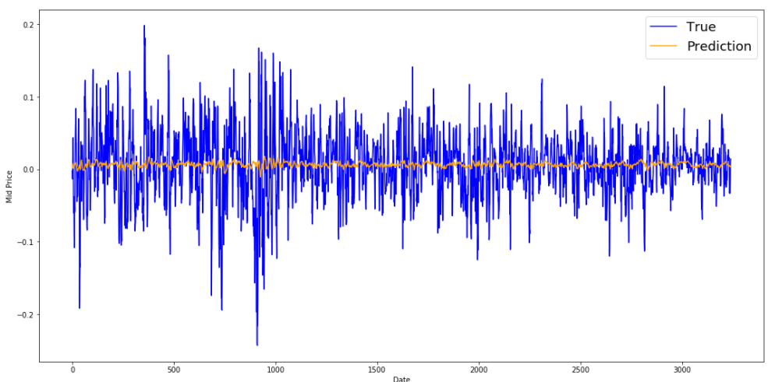
Figure 11: Linear model training set graph

Test set
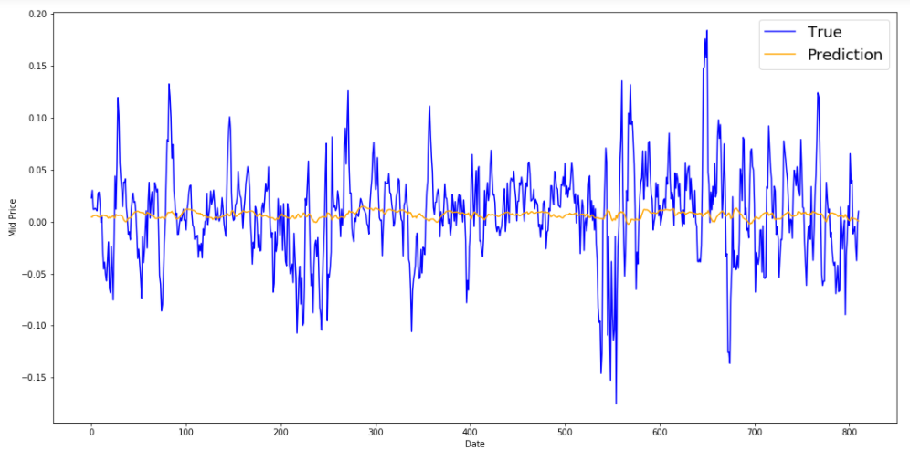
Figure 12: Linear model test set graph

Interpretation:
This model represents poor results, it fails to keep up with the stock price movements in the training and test data. This is said to be due to the lack of a strong correlation between the variables in the table.

- DecisionTree Regressor
We import the Decision Tree Regressor function from the sklearn.tree library and then fit it on the training data.
For this algorithm we tried several values for the max depth and we observed their scores:

max_depth= 3
0.044596623640908106
-0.08045649880978467

max_depth= 5
0.1104710300192725
-0.23507095126323896

max_depth= 10
0.2810554143195267
-0.381830666851992

max_depth= 15
0.5181790603357304
-0.7483634056825159

max_depth= 20
0.7929570850030065
-0.9888126281003026

max_depth= 25
0.9429413278041754
-1.0795986691918924

We decided to visualize the results of max depth = 20

Training set

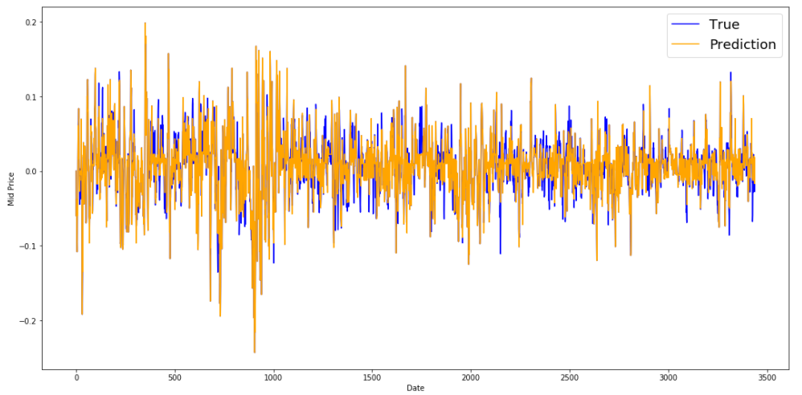
Figure 13: Decision Tree training set graph

Test Set
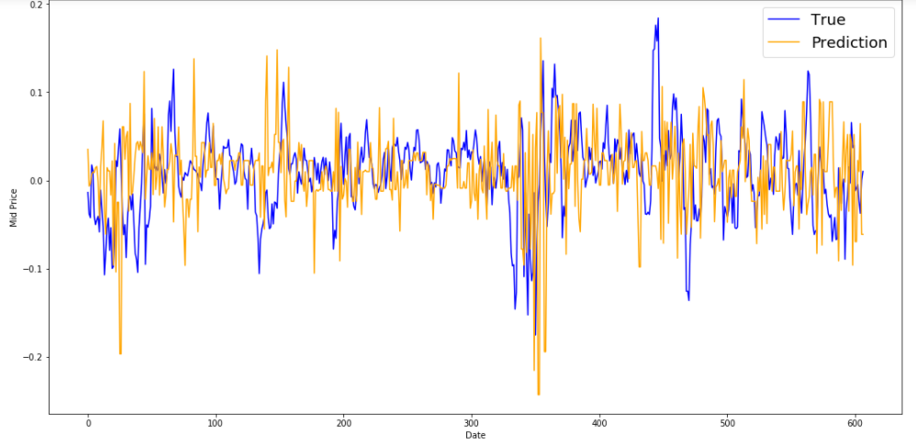
Figure 14: Decision Tree test set graph

Interpretation:
This model has a good training score, but a low test score (over-learning problem). The visualization graphs validate these results. The model is able to follow price fluctuations in the training data, but it has difficulty with the test data, which cannot predict large fluctuations.

- Random Forest Regressor
We import the Random Forest Regressor function from the sklearn.ensemble library, then we created the model with 200 as number of estimators and finally fit it on the training data.
For this algorithm we varied the number of Max Features and Max depth to keep the combination of parameters that give the best result

{'max_depth': 3, 'max_features': 4, 'n_estimators': 200, 'random_state': 42}
0.056221017400645
-0.034801729770259415
{'max_depth': 3, 'max_features': 6, 'n_estimators': 200, 'random_state': 42}
0.059744966364239205
-0.05584243128023103
{'max_depth': 5, 'max_features': 4, 'n_estimators': 200, 'random_state': 42}
0.11273150217114003
-0.05729628222999162
{'max_depth': 5, 'max_features': 6, 'n_estimators': 200, 'random_state': 42}
0.11997420532983749
-0.08494490699559054
{'max_depth': 10, 'max_features': 4, 'n_estimators': 200, 'random_state': 42}
0.2865085843519457
-0.11188851687668076
{'max_depth': 10, 'max_features': 6, 'n_estimators': 200, 'random_state': 42}
0.2971946643417608
-0.13255812655841548
{'max_depth': 15, 'max_features': 4, 'n_estimators': 200, 'random_state': 42}
0.5085146138646988
-0.13363374111549553
{'max_depth': 15, 'max_features': 6, 'n_estimators': 200, 'random_state': 42}
0.5115130241692214
-0.14982438406043164
{'max_depth': 20, 'max_features': 4, 'n_estimators': 200, 'random_state': 42}
0.7021616974201208
-0.15753813254873417
{'max_depth': 20, 'max_features': 6, 'n_estimators': 200, 'random_state': 42}
0.7075076401113893
-0.15296941632033345
{'max_depth': 25, 'max_features': 4, 'n_estimators': 200, 'random_state': 42}
0.817163996764916
-0.1595117889420159
{'max_depth': 25, 'max_features': 6, 'n_estimators': 200, 'random_state': 42}
0.8187567202749778
-0.18855734498063859

We decided to keep the following parameters: max features = 4, max depth = 25

Training set
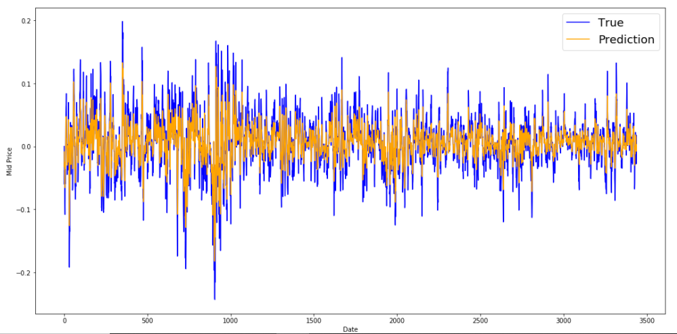

Figure 15: Random Forest training set graph

Test set
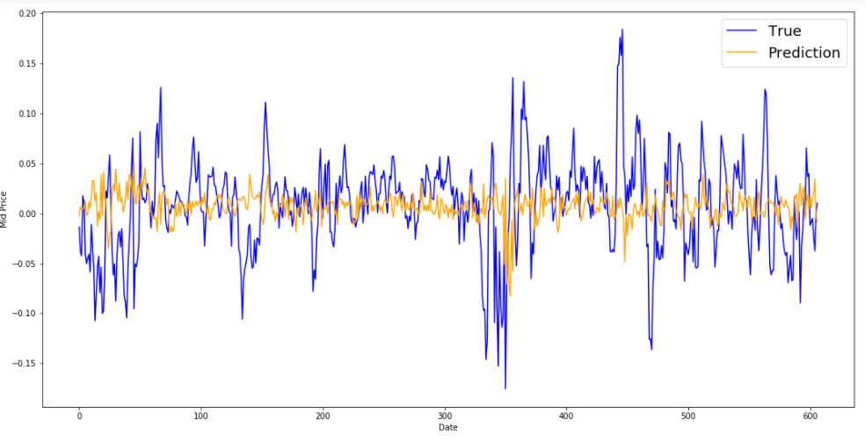
Figure 16: Random Forest test set graph

Interpretation:
We used the best hyper parameters according to the scores they provide. This time, this model does not encounter the problem of over-learning. Nevertheless, the results on the test data remain weak and fail to predict strong fluctuations in the price.

- K-Neighbors

We import the KNeighborsRegressor function from the sklearn.neighbors. For this algorithm we have given several values to the number parameter of Neighbours which gives:

n_neighbors = 2
train, test scores
0.5769499712664358
-0.6373813646326676

n_neighbors = 3
train, test scores
0.4041066197588664
-0.4349319817063384

n_neighbors = 4
train, test scores
0.3158024971161992
-0.334986121347135

n_neighbors = 5
train, test scores
0.26537757257931793
-0.2842083980487191

n_neighbors = 6
train, test scores
0.23471836570589077
-0.24239176353143432

n_neighbors = 7
train, test scores
0.21210234843101383
-0.22487386576851898

n_neighbors = 8
train, test scores
0.18936087806767954
-0.18847545188996895

n_neighbors = 9
train, test scores
0.1693770811803671
-0.17349601017994054

n_neighbors = 10
train, test scores
0.15530560536667137
-0.17121644557705573

n_neighbors = 11
train, test scores
0.1424713882844012
-0.15163693924813737

n_neighbors = 12
train, test scores
0.1277674589502681
-0.1501611461458776

n_neighbors = 13
train, test scores
0.11772323648725236
-0.13707311770810882

n_neighbors = 14
train, test scores
0.1055843021675762
-0.1313965598799569

n_neighbors = 15
train, test scores
0.10144225293012654
-0.1281650634174798

n_neighbors = 16
train, test scores
0.09666549528261137
-0.12273287466468341

n_neighbors = 17
train, test scores
0.0945309856542208
-0.10462077336970821

n_neighbors = 18
train, test scores
0.09127186668495268
-0.09812470586686817

n_neighbors = 19
train, test scores
0.08743126704187743
-0.08947618437215388

n_neighbors = 20
train, test scores
0.0827187624689152
-0.09229983379551165

n_neighbors = 21
train, test scores
0.07925947722858795
-0.09284403227467042

n_neighbors = 22
train, test scores
0.07819156162873853
-0.0846531689801151

n_neighbors = 23
train, test scores
0.07352568590159991
-0.0880005213406223

n_neighbors = 24
train, test scores
0.07071538402250643
-0.09097467714531793

n_neighbors = 25
train, test scores
0.06971250279152152
-0.08613703069815326

We decided to take my value 3 which gives the best score among the other values which gives the following graphs:

Training set
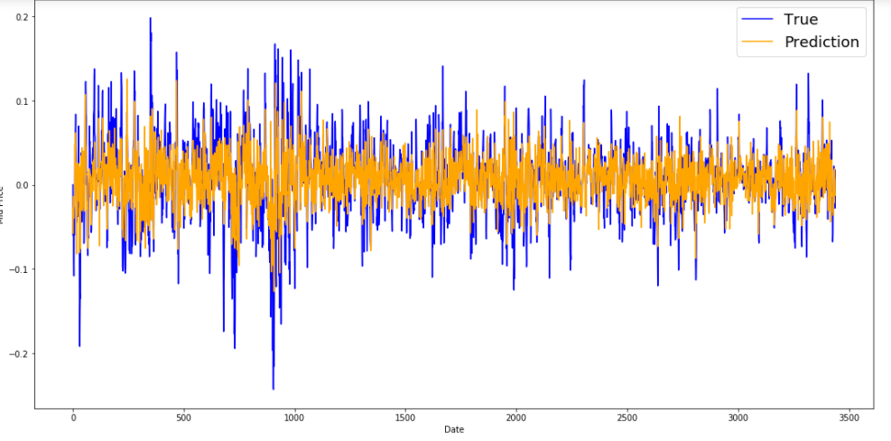
Figure 17: K-Neighbors training set graph

Test Set
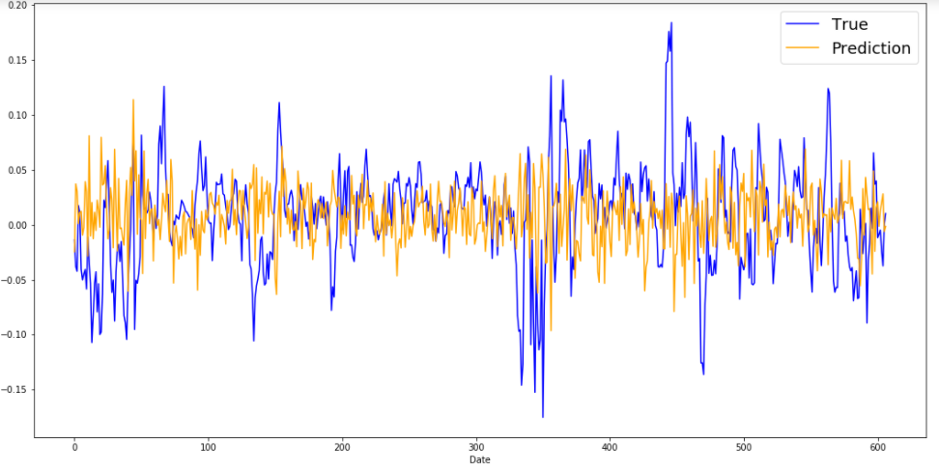
Figure 18: K-Neighbors test set graph

Interpretation:
Even using different numbers of neighbours, the results of this model are poor on training and testing data.

- Neural Network
We constructed this model by initiating it as a sequential model then added 3 layers.
The first layer contains 100 neurons, 25 in the second and only 1 result neuron in the third.
We opted for Adam as an optimizer and the mean squared error to calculate the loss function.
We fitted then the model on our scaled training data and let it run for 300 epochs.

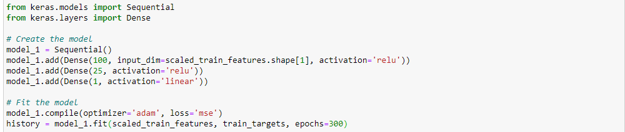
Figure 19: Model Implementation
Which gives the following loss curve:
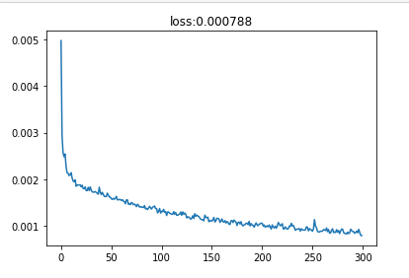
Figure 20: Loss curve

With the following graphs:

Training Set
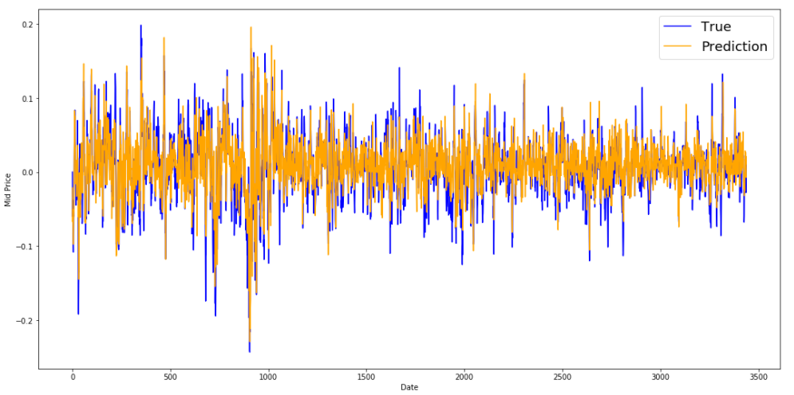
Figure 21: Neural Network Training set graph

Test Set
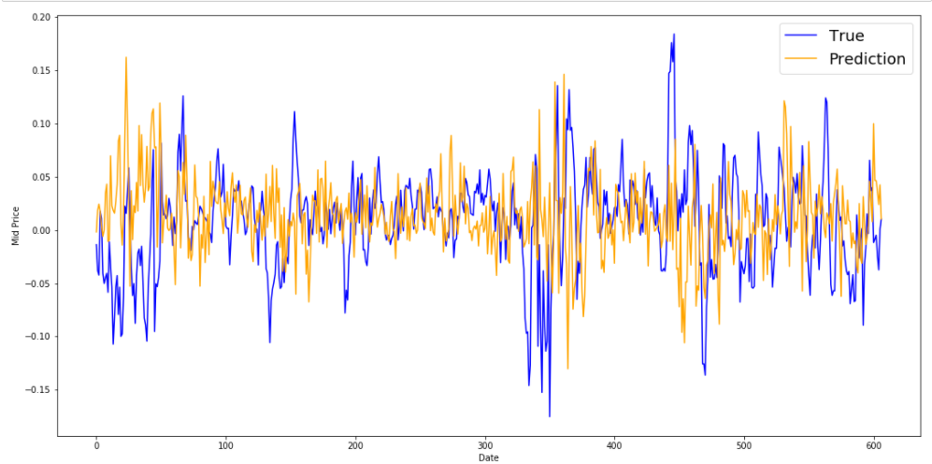
Figure 22: Neural Network Test set graph

Interpretation:
The results are average, we notice that the model manages to follow some strong fluctuations in the test data even if the precision is missing.

- Recurrent neural network : LSTM
The first layer contains 32 neurons, 116 in the second and1 in the third. We also added an linear output activation function.
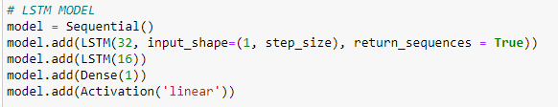
Figure 23: LSTM algorithm code

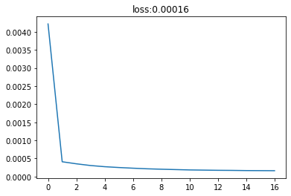
Which gives the following loss curve:
Figure 24: LSTM loss curve

On AAPL dataset, LSTM model got the following results:
- Training RMSE : 1.45
- Test RMSE : 1.55
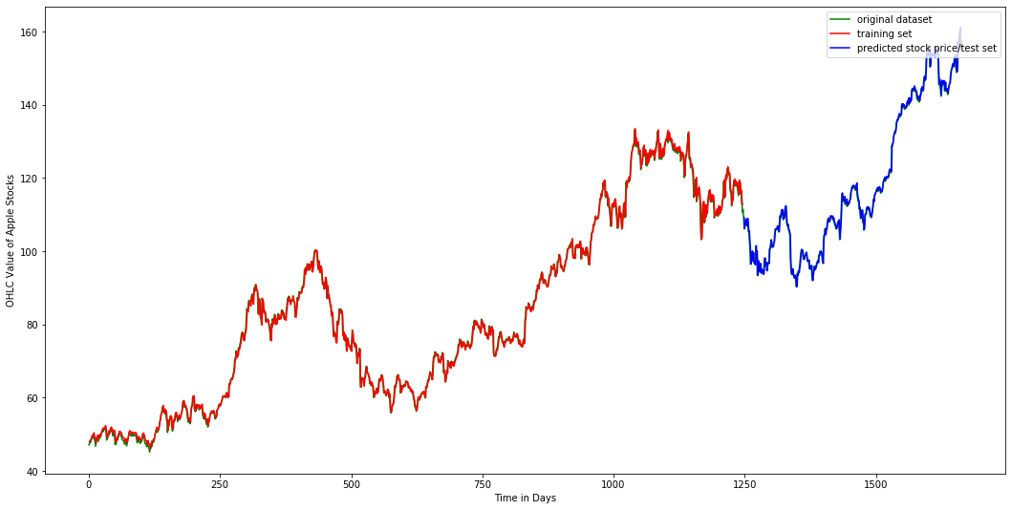
- Training + test Set:
Figure 25: LSTM Training+Test set graph (Apple dataset)
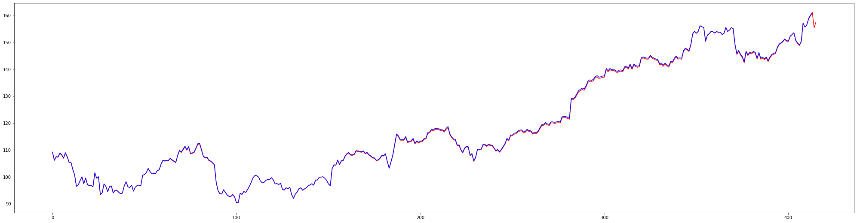
- Zoomedtestingset:
Figure 26: LSTM Training+Test set graph (Apple dataset)

- Testing on the COCA-COLA dataset:
- RMSE = 0.45
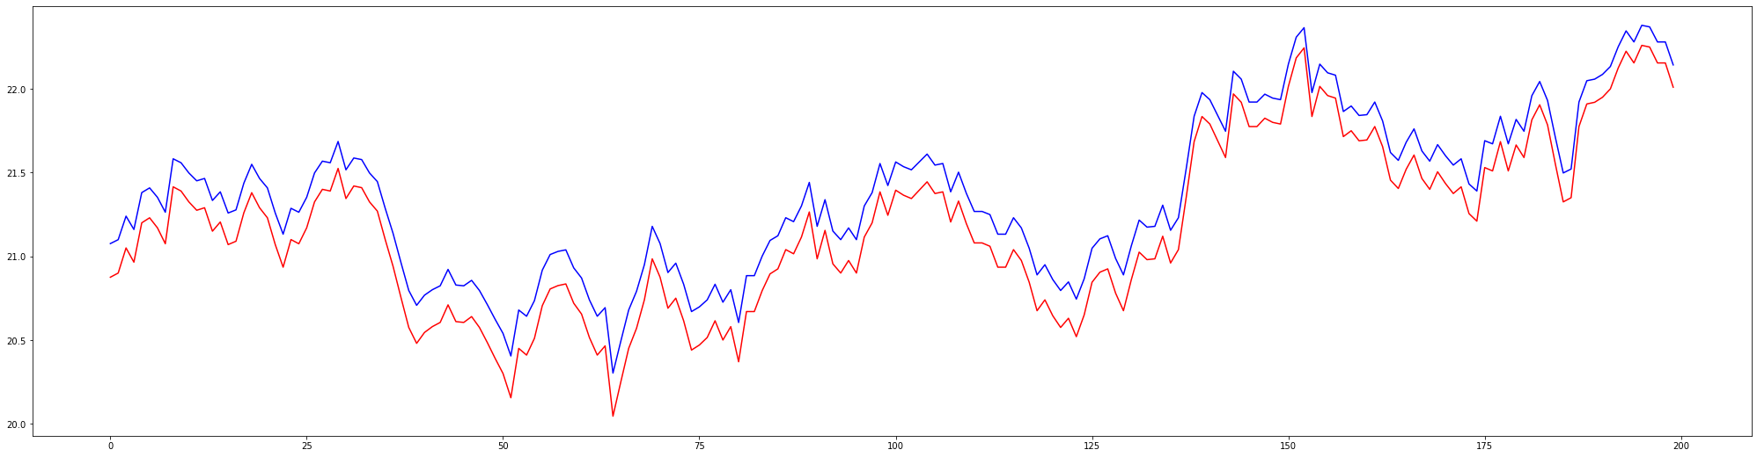
- Row 200 to 400 results: (red: Original value, blue: Predicted value)
Figure 27: LSTM Test set graph (Coca-Cola dataset: row 200 to 400)

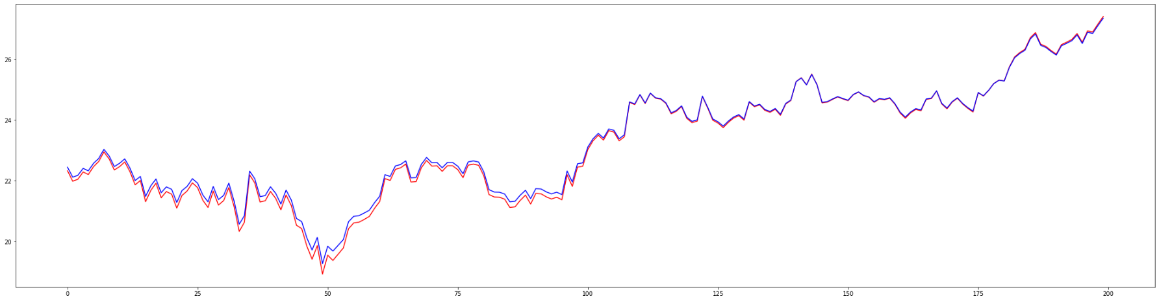
- Row 1000 to 1200 results:
Figure 28: LSTM Test set graph (Coca-Cola dataset: row 1000 to 1200)

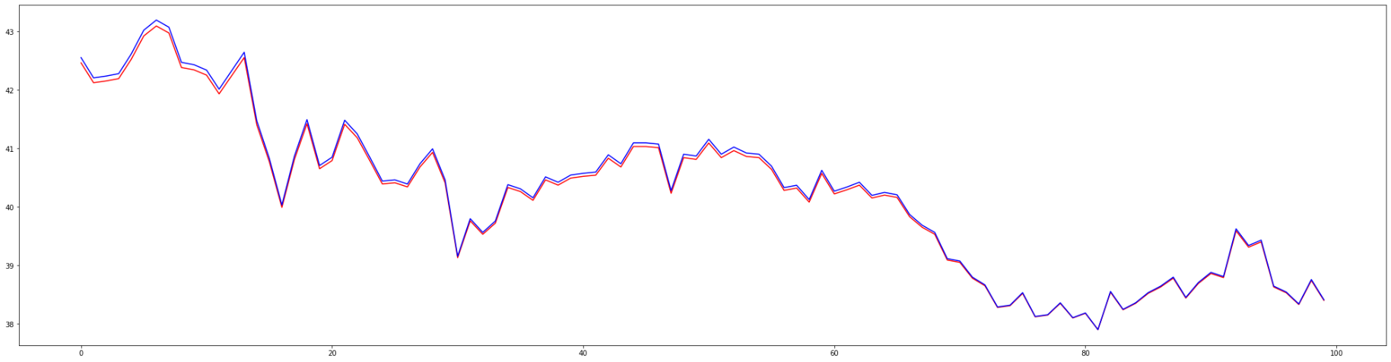
- Row 2100 to 2200 results:
Figure 29: LSTM Test set graph (Coca-Cola dataset: row 2100 to 2200)

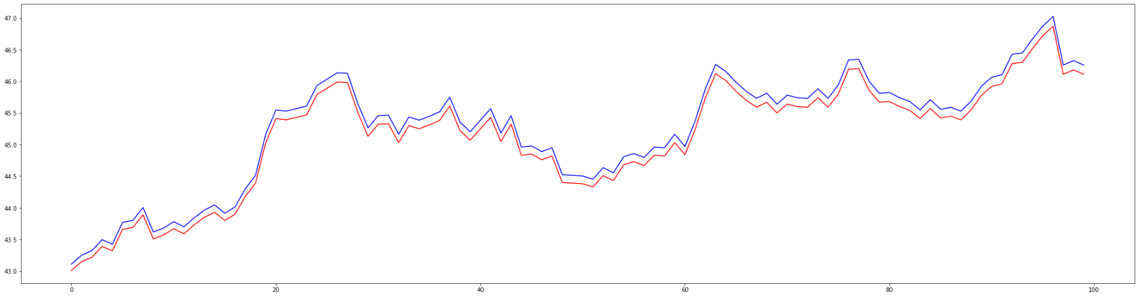
- Row 3100 to 3200 results:
Figure 30: LSTM Test set graph (Coca-Cola dataset: row 3100 to 3200)

Interpretation:
Overall, the LSTM model did very well with some excellent results compared to all the other models used in this project. The results started with a low error score of 1.45 and 1.55 for the training and testing Apple dataset respectively, and an error of 0.45 when testing on the Coca-Cola dataset. The graphs also support these results with the original and predicted price almost overlapping on both datasets, which shows how effective the LSTM model is in the prediction of stock prices.

Conclusion and prospect

The genuine need for profitable business is reflected in stock market forecasting. Predictions are always useful in reducing the risk factor in any business situation. Historical data and previous company trends can be used to identify risk factors.
We employed different kinds of machine learning algorithms (Linear regression, recurrent neural networks, decision tree, random forest, K-neighbours, LSTM…) to compare between these different models and their ability to make accurate forecasts on stock prices such as Apple (AAPL)and The Coca-Cola Company (KO) based on their historical data.

At the top, comes the LSTM model with the best results that shows in a low error score and almost overlapping graphs for original and predicted values. Comes after, Neural network and decision tree with medium results as the two models have a hard time predicting acute fluctuations in the price of the stock. The rest of the other models had mediocre results, especially the linear regression that failed completely at handling the price changes.

This project allowed us to discover plenty of algorithms and technics used for the prediction of stock changes, but there is still plenty of other models to try like the Convolutional Neural Network (CNN), other variables we can try like using some financial indexes or other financial indicators. Sentimental analysis can also be used to give insight about the trend of a stock since the people opinion is now an important factor in the price changing along with Recommendations given by some financial analysts.

Finally, all of the results we have got goes to show how important it is to choose the right model and hyperparameters for the problem at hand, and how it can affect the results.

References

- https://www.sas.com/en_gb/insights/articles/analytics/machine-learning-algorithms.html
- https://machinelearningmastery.com/a-tour-of-machine-learning-algorithms
- https://en.wikipedia.org/wiki/Long_short-term_memory
- https://en.wikipedia.org/wiki/Recurrent_neural_network

